**HOMEWORK UNITS 10 – 16**

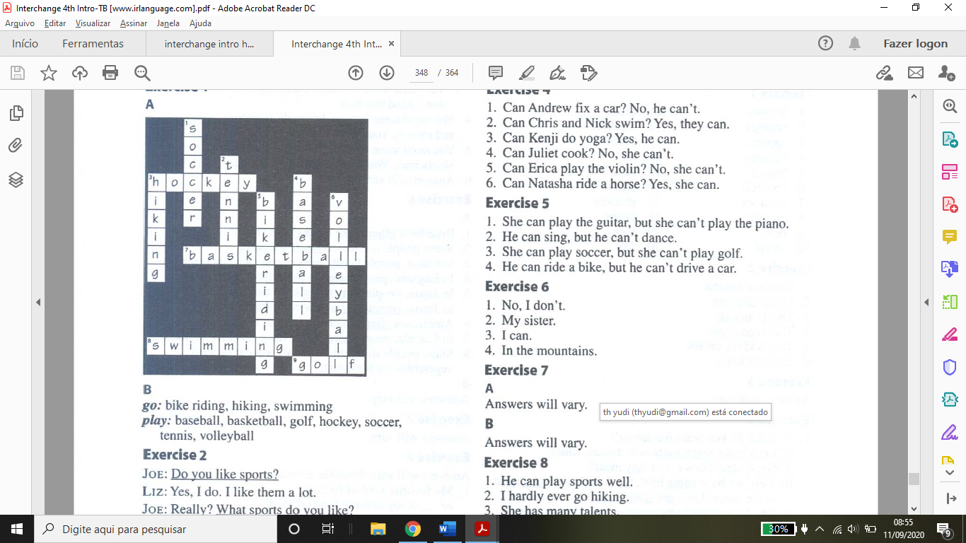**Page 1**

**B-) Wich sports in a parta A follow go? Wich sports follow play? Complete the chart**

**Go:** bike, riding, hiking, swimming

**Play:** baseball, basketball, golf, hockey, soccer, tennis, volleyball

**Page 2**

**Complete the conversation. Use the questions in the box.**

- Do you like sports? (examples)

- What sports do you like?

- When do you usually practice?

- Who do you practice with?

- Does your sister play volleyball, too?

**Unscramble the questions. Then answer with your own information.**

- Do you like baseball?

- ..............................

- What sports do you watch?

- .............................

- What sports do you play?

- .............................

- How often do you go snowboarding?

- .............................

- Who do you play sports with?

- .............................

**Page 3**

**Write sentences about these people. Use can, can’t, about.**

1-) She can play the guitar, but she cant’ play the piano. (example)

2-) He can sing, but he can’t dance.

3-) She can play soccer, but she cant’ play golf.

4-) He can ride a bike, but he can’t drive a car.

**Choose the correct responses.**

1-) No, i don’t. (example)

2-) My sister.

3-) I can.

4-) In the mountains.

**Page 4**

**Write each sentence a different way. Use the sentence in the box.**

1-) He can play sports well. (example)

2-) I hardly ever go hiking.

3-) She has many talents.

4-) I love it.

5-) He can’t sing at all.

6-) She tells good jokes.

**Answer these questions with short answer. Use your own information.**

.................................................

**What can your friends and Family do? What can’t they do? Write sentences.**

.................................................

**Page 5**

**A: Can you do these things? Check “x” can or can’t.**

................................

**B: Write sentences about the things in part A.**

...........................................

**Page 6**

**A: Put the months in the box in time order.**

1-) January (example)

2-) February

3-) March

4-) April

5-) May

6-) June

7-) July

8-) August

9-) September

10-) October

11-) November

12-) December

**B: When are the seasons in your country? Write the months for each season.**

**Spring:** March, April, May, June

**Summer:** June, July, August, September

**Fall:** September, October, November, December

**Winter:** December, January, February, March

**C: Write each date a diferente way**

1-) March twelfth (example)

2-) April eleventh

3-) January sixteenth

4-) February ninth

5-) October first

6-) May twenty-second

7-) July third

8-) August thirtieth

**Page 7**

**It’s January first. How old are these people going to be on their next birthdays?**

1-) Alex is going to be seventy-seven on March fifteenth. (example)

2-) Anita is going to be twenty-six on July twenty-seventh.

3-) Peggy and Patty are going to be nineteen on September sixth.

4-) I’m going to be.........................

**Read Beth’s calendar. Write sentences about her plans. Use the words in parentheses.**

1-) On June second, she’s going to play golf after work. (example)

2-) On June third, she’s going to have lunch with Tony.

3-) On June seventh, she’s going to go shopping with Julie.

4-) On June eighth, she’s going to meet John for dinner.

5-) On June eleventh, she’s goingo to work late.

6-) On June thirteenth, she’s going to go to Sam’s party.

7-) On June sixteenth, she’s going to see a movie with Tony.

8-) On June twenty-first, she’s going to have a Family picnic.

9-) On June twenty-fourth, she’s going to buy Paula’s birthday present.

10-) On June twenty-fifth, she’s going to go to Paula’s birthday dinner.

**Page 8**

**Complete these sentences. Use the correct formo f be going to and the verbs in parentheses.**

1-) is going to be (example)

2-) are going to see / ‘re (are) going to eat.

3-) are going to visit / ‘re (are) going to drive / ‘re (are) going to go / ‘s is going to love / ‘s not (is not or isn’t) going to like / ‘re (are) going to watch / are going to go.

4-) ‘m (am) going to sleep / ‘m (am) going to read / ‘m (am) going to take / are going to study.

**Page 9**

**Complete these conversations. Write questions with be going to.**

1-) What are you going to do this weekend? (example) / Where are you going to stay? / What are you going to do? / Is Marjorie going to go with you?

2-) Where is it going to be? / when is it going to start / Is Bob going to be there? / Are you going to bake a cake?

**Page 10**

A: What are these people going to do next weekend? Write sentences.

1-) They are going to work out.

2-) He’s going to cook.

3-) She’s going to read. / She’s going to study.

4-) They’re going to play tennis.

5-) They’re going to go shopping.

6-) She’s going to paint.

7-) They’re going to fix a car.

8-) They’re going to play volleyball.

9-) They’re going to play chess.

**B: What are going to do next weekend? How about your Family and friends? Write sentences.**

....................................

**Page 11**

**Are you going to do anything special on these holidays or special occasions? Write sentences. Use the phrases in the box or your own information.**

.............................

**Page 12**

**Label the parts of the body. Use the words in the box.**

1-) hair (example)

2-) mouth

3-) neck

4-) stomach

5-) fingers

6-) leg

7-) toes

8-) eye

9-) ear

10-) nose

11-) teeth

12-) shoulder

13-) elbow

14-) arm

15-) hand

16-) foot

**Page 13**

**What’s wrong with these people? Write sentences.**

1-) He has an earache.

2-) She has a sore throat.

3-) She has a stomachache.

4-) She has a headache.

5-) He has a toothache.

6-) She has a cold.

**Page 14**

**Complete the conversations. Use the questions ans sentences in the box.**

1-) I’m fine, thanks. How about you

- What’s wrong?

- That’s too bad. Are you going to see a doctor?

- Ok. Get some rest.

2-) How do you feel tonight?

- I’m glad to hear that.

- So, are you going to go to school tomorrow?

- Great. See you tomorrow.

**Page 15**

**Complete the sentences with the correct medications.**

1-) eyedrops (example)

2-) cough drops / cough syrup

3-) aspirin

4-) muscle cream

5-) antacid

6-) cold pills

**Write each sentence a different way. Use the sentences in the box.**

1-) Whats’ wrong? (example)

2-) I’m not happy.

3-) I’m sorry to hear that.

4-) I have a stomachache.

5-) I have a sore throat.

6-) My head feels terrible.

7-) I’m glad to hear that.

8-) I’m very tired.

**Page 16**

**Give these people advice. Use the phrases in the box.**

1-) Don’t work too hard. (example)

2-) Don’t go outside.

3-) Have a hot drink.

4-) Don’t lift heavy things.

5-) Go home early.

6-) Don’t stay up late.

7-) Go to the grocery store.

8-) Drink some water.

**Page 17**

**Write two pieces of advices for each problem.**

........................................

**How healthy and happy are you? Complete the survey.**

**....................................**

**Page 18**

**A: Complete these sentences with the correct places. Write one letter on each line.**

1-) gas station (example)

2-) bank

3-) bookstore

4-) post office

5-) supermarket

6-) hotel

7-) drugstore

8-) restaurant

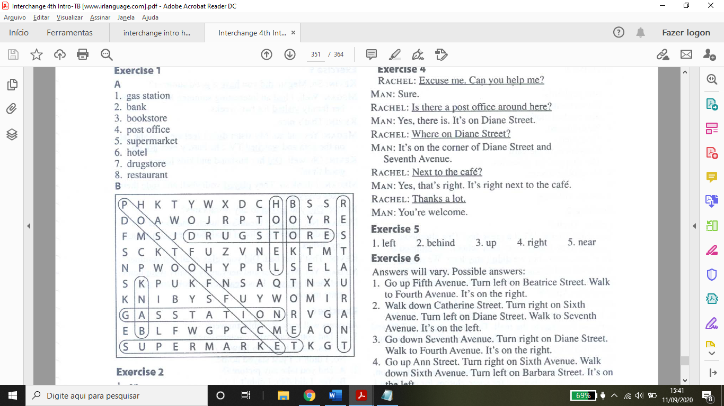

**Page 19**

**Look at the map. Complete the sentences with the prepositions in the box.**

1-) on (example)

2-) behind

3-) on the corner of

4-) between

5-) next to

6-) across from

**Page 20**

**A: Look at the map in Exercise 2 again. Where is each place? Write two sentences.**

...................................

**B: Where is your school. Draw a map. Then write two sentences.**

.......................

**Page 21**

**Complete the conversation. Use the sentences and questions in the box.**

- Excuse-me. Can you help me? (example)

- Is there a post office around here?

- Where on Diane Street?

- Next to the café.

- Thanks a lot.

**Complete the sentences with the opposites.**

1-) left (example)

2-) behind

3-) up

4-) right

5-) near.

**Page 22**

Look at the map. Give these people directions. Use the phrases and sentences in the box.

(Answers will vary)

1-) Go up Fifth Avenue. Turn left on Beatrice Street. Walk to Fourth Avenue. It’s on the right.

2-) Walk down Catherine Street. Turn right on Sixth Avenue. Turn left on Diane Street. Walk to Seventh Avenue. It’s on the left.

3-) Go down Seventh Avenue. Turn right on Diane Street. Walk to Fourth Avenue. It’s on the right.

4-) Go up Ann Street. Turn right on Sixth Avenue. Walk down Sixth Avenue. Turn left on Barbara Street. It’s on the left.

**Page 23**

**Complete the chart.**

**Present:** eat, get up

**Past:** bought (example), came, did, felt

**Present:** ride, see

Past: went, had, read, sat

Complete the conversation. Use the simple past forms of the verb in parentheses.

Kevin: did / have (example)

Megan: had / visited

Megan: didn’t feel / sat / watched / got up /

Kevin: Did / have

Megan: played / rode /

Kevin: Did / go out

Megan: cooked / ate / didn’t wash

Kevin: Did / relax

Megan: went / relaxed / read / saw

**Page 24**

**Unscramble the questions about last summer. Then answer with your own information.**

1-) Did you go anywhere interesting? (example)

2-) Did you take any pictures?

3-) Did you buy anything interesting?

4-) Did you eat any new foods?

5-) Did you play any games?

6-) Did you play any sports?

7-) Did you meet any interesting people?

8-) Did you read any good books?

9-) Did you see any good movies?

**Page 25**

**A: Greg and Grant did different activities last summer. Write sentences about then.**

**(answers will vary)**

1-) Greg got up early every day.

2-) Greg played tennis.

3-) Greg went hiking.

4-) Greg rode a horse.

5-) Grant got up late every day.

6-) Grant read books.

7-) Grant ate pizza.

8-) Grant saw a movie.

**B: Write sentences about your activities last summer.**

................................

**Page 26**

**Complete the conversation. Use the sentences in the box.**

Luis: No, i wasn’t. I was born in the Caribbeann. (example)

Luis: No, i’m from the Dominican Republic.

Luis: I was born in Santo Domingo.

Luis: Yes, they were. We were all born there.

Luis: I came here to study English.

Luis: I moved here in 2007.

Luis: I was sixteen.

Luis: No, it wasn’t. I loved it.

**Page 27**

**Complete the conversations with was, wasn’t, were or weren’t.**

1-) weren’t (example) / wasn’t / was / was / was / were / weren’t / was / was

2-) were / was / were / was / were / wasn’t / was / was / were

3-) were / wasn’t / were / was / were / wasn’t / was / was / was

**Page 28**

**Write four sentences about each person.**

1-) Frida Kahlo was a painter. She was born in 1907 in Mexico.

She married painter Diego Rivera in 1929. She died in 1954.

2-) Jackie Robinson was a baseball player. He was born in 1919 in the U.S.

He was the first African American to play modern major league baseball in 1947. He died in 1972.

3-) Audrey Hepburn was na actress. She was born in 1929 in Belgium.

She was in the movie Breakfast at Tiffany’s in 1961. She died in 1993.

4-) Bruce Lee was na actor. He was born in 1940 in the U.S.

He was in the movie Enter the Dragon in 1973. He died in 1973.

5-) Coco Chanel was a fashion designer. She was born in 1883 in France.

She opened her first shop in Paris in 1909. She died in 1971.

6-) Mark Twain was a writer. He was born in 1835 in the U.S.

He wrote The Adventures of Huckeberry Finn in 1885. He died in 1910.

**Page 29**

**Do you think theses classes are easy, difficult, interesting, or boring? Complete the chart. Then add one more class to each column.**

......................

**Complete these questions. Use the words in the box.**

1-) What (example)

2-) Who

3-) When

4-) Where

5-) Why

6-) How

7-) How old

**Page 30**

**Unscramble the questions about your elementary school days. Then answer with your information.**

1-) How was your first day at school? (example)

2-) Who was your favorite teacher?

3-) What was your favorite class?

4-) Who were your best friend?

5-) Where you did spend your free time?

6-) When did you finish elementary school?

**Page 31**

**A: Complete the questions with did, was, or were. Then answer the questions. Use short answer.**

1-) Were (example)

2-) Did

3-) Did

4-) Was

5-) Did

6-) Were

7-) Were

8-) Did

9-) Did

10-) Did

**B: Write sentences about your childhood.**

......................

**Page 32**

**Complete this interview with a Broadway actor. Use was, were, did,or didn’t. Then practice the interview with a partner.**

(follow the vídeo)

**Check X all correct answers.**

(follow the vídeo)

**You’re interviewing a Young actor. First, match the questions with the answers. Then, practice the interview with a partner.**

1-) B (example)

2-) C

3-) D

4-) E

5-) A

**Page 33**

**Make a phone conversation. Use the sentences and questions in the box.**

**Receptionist:** Good morning. Lane Retail Group. (example)

**Ms Perez:** Good morning. Is Mr Adams there? (example)

**Receptionist:** I’m sorry, but Mr Adams is in a meeting.

**Ms Perez:** Oh.

**Receptionist:** Can i take a message?

**Ms Perez:** Yes. This is Ana Perez. Please ask him to call me.

**Receptionist:** Does Mr Adams have your number?

**Ms Perez:** I don’t think so. It’s 604-555-0662.

**Receptionist:** 604-555-0662. I’ll give him your message.

**Ms Perez:** Thank you very much.

**Receptionist:** You’re welcome. Good-bye.

**Ms Perez:** Good-bye

**Page 34**

**Scott called his friends yesterday. Where are they? Complete the conversations. Use the words in the box.**

1-) at work (example)

2-) in class

3-) on vacation

4-) in the hospital

5-) at the mall

6-) in the shower

**Page 35**

**A: Complete the chart.**

**Subjects:** you, they

**Objects:** me (example), him, her, us

**B: Complete the sentences with the correct words in parentheses.**

1-) him

2-) she

3-) I

4-) us

5-) they

**Jim is checking his voice mail messages. Complete the messages with the correct pronouns.**

**Bob’s message:** me (example), her, we, us, me

**Allie’s message:** I, us, me

**Derek’s message:** he, I, you, me

**Page 36**

**Complete the phone conversation. Use the words in the box.**

**Ray:** can (example) / please

**Sam:** but / in / her /

**Ray:** This / call / at

**Sam:** have

**Ray:** does

**Complete the excuses. Use your won ideas.**

...................................

Page 37

**Imagine your friends invite you to do these things. Accept or refuse their invitations. Use the phrases and sentences in the chart.**

...........................

**Write each sentence a different way. Use the sentences in the box.**

1-) Hi, this is Amy. (example)

2-) Is Barbara there?

3-) Do you want to see a movie?

4-) I’d like to go to the movies.

5-) I’m busy.

6-) Can i take a message?

**Page 38**

**Answer the questions. Write sentences with like to, want to, and need to.**

.......................