**HOMEWORK UNITS 1 – 9**

**Page 01**

**Choose the correct responses**

1-) Hello (example)

2-) I’m Jake Willians

3-) Fine, thanks.

4-) R-O-G-E-R-S

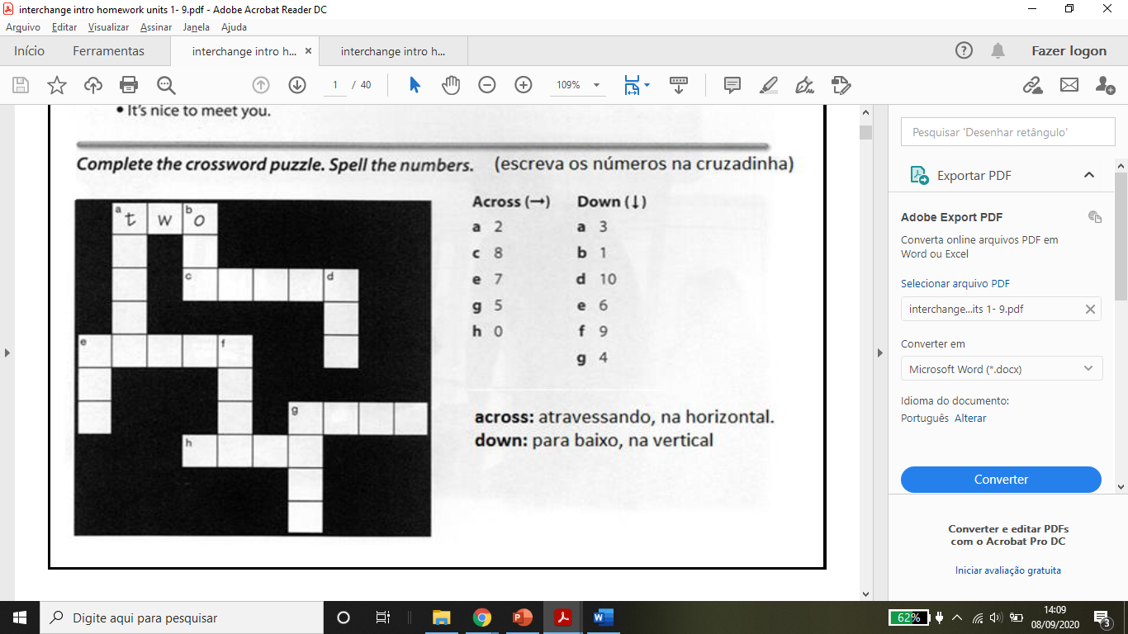5-) It’s nice to meet you

**H**

**R**

**E**

**E**

**I**

**R**

**U**

**X**

**E**

**V**

**IE**

**F**

**O**

**R**

**Z**

**E**

**N**

**I**

**S**

**V**

**E**

**N**

**T**

**N**

**E**

**G**

**I**

**H**

**E**

**N**

**Page 2**

**Complete the conversations. Use the words in the box.**

1-) Me (example)

- You

- I’m not.

- He’s

- I’m

2-) Are

- Am

- Is

- You’re

- It’s

**Complete the conversation. Use the question in box**

- Are you Ashley Nevins? (example)

- What’s your name?

- How do you spell your first name?

- And how do you spell your last name?

- What’s your phone number?

- And what’s your email address?

**Page 3**

**Complete the conversations. Use these words:**

1-) Yes, it is

2-) No it’s not.

3-) It’s

4-) They’re

5-) Yes, i’am

6-) Yes, they are

7-) No, i’m not

**Complete the conversation. Use these words:**

- It’s (example)

- you

- you’re

- this

- ‘s

- a

- these

- they’re

- an

**Page 4**

**Complete com: is, are, not, it, they where**

1-) is (example)

- it

- not

- is

- it

2-) is (example)

- it’s

- Where

- it

- is

3-) are

- not

- Are

- they

4-) are

- are

- are

**Page 5**

**Answer the questions. Use your information:**

1-) No, i,m not. I’m a student.

2-) No, it’s not. My name is....

3-) Yes, it is. (or) No, it’s not.

4-) No, it’sn not. My phone number is.....

5-) No, i’m not. I1m in na English class.

**Complete the sentences. Use the prepositions in the box.**

1-) in

2-) behind

3-) on

4-) under

5-) in front

6-) next to

**Page 6**

**Where are these things?**

1-) A: Where is the briefcase? (example)

B: It’s next to the television. (example)

2-) A: Where are the books?

B: They’re under the table.

3-) A: Where is the cell phone?

B: It’s in the purse.

4-) A: Where are the Keys?

B: They’re on the briefcase.

5-) A: Where is the camera?

B: It’s in front of the television.

6-) A: Where are the sunglasses?

B: They’re behind the chair.

**Write two more questions and answer about the Picture.**

1-) A: Where is the wastebasket?

B: It’s next to the door?

2-) A: Where are the pens?

B: They’re on the table.

**Page 7**

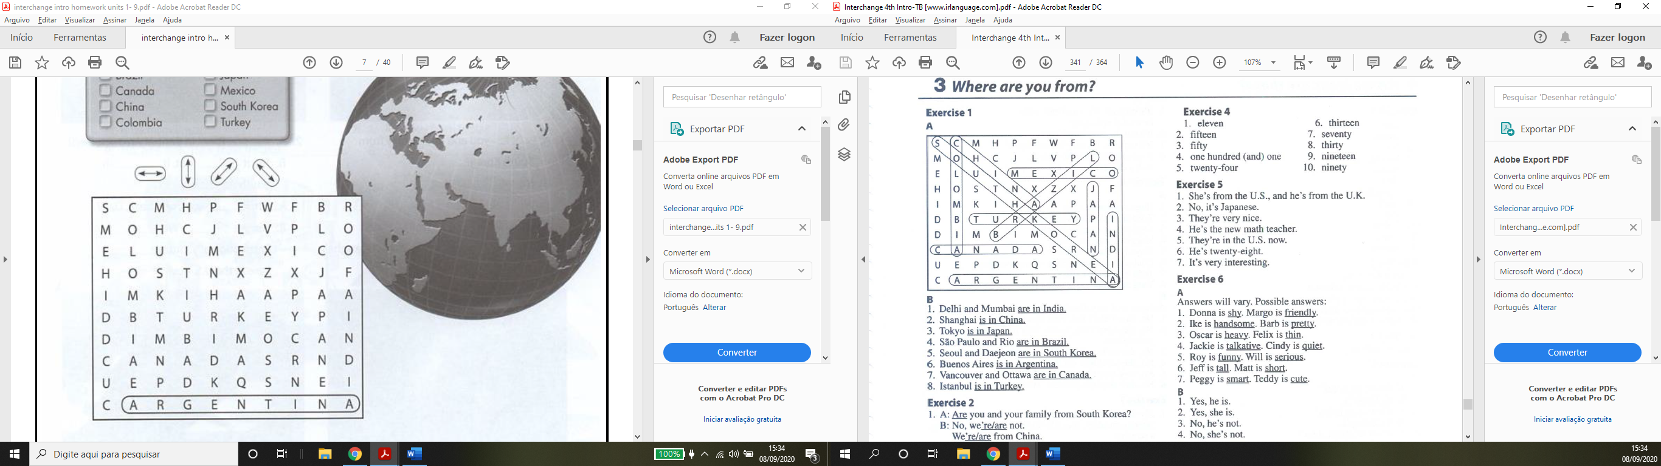

Where arte these cities? Complete the sentences with the countries in Part A.

1-) are in India (example)

2-) is in China.

3-) is in Japan.

4-) are in Brazil.

5-) are in South Korea.

6-) is in Argentina.

7-) are in Canada.

8-) is in Turkey.

**Page 8**

Answer the questions

1-) No he’s not. He’s from Ireland (example)

2-) Yes, they are. They’re from Delhi.

3-) No, she’s not. She’s from USA.

4-) No, she’s not. She is in Japan.

5-) NO, they’re not. They’re in New York.

6-) Yes, they’re. They’re in Perth.

**Page 9**

**Spell the numbers**

1-) eleven

2-) fifteen

3-) fifty

4-) one hundred one

5-) twenty-four

6-) thirteen

7-) seventy

8-) thirty

9-) nineteen

10-) ninety

**Complete the conversation with the correct answers**

1-) She’s from the U.S., and he’s from the U.K.

2-) No, it’s Japanese.

3-) They’re very nice.

4-) He’s the new math teacher.

5-) They’re in the U.S. now.

6-) He’s twenty-eight.

7-) It’s very interesting.

**Page 10**

**Write sentences about the people in the pictures. Use the words in the box.**

1-) Shy (example)

- friendly (example)

2-) handsome

- pretty

3-) heavy

- thin

4-) talkative

- quiet

5-) funny

- serious

6-) tal

- short

7-) smart

- cute

**Answer the questions**

1-) Yes, he is. (example)

2-) Yes, she is.

3-) No, he’s not.

4-) No, she’s not.

5-) Yes, they are.

6-) No, they’re not.

7-) Yes, I am or No, I am not.

8-) Yes, I am or No, I am not.

**Page 11**

**Complete the conversations. Use the words in the boxes.**

1-) A: What’s (example)

- B: He’s / His

- A: Where / Is

- B: not

2-) B: we / we’re

A: What’s

B: My / Her / are

**Answer the question. Use your own information.**

1-) I’m from....

2-) My first language is...

3-) I’m...

4-) My teacher is from...

5-) My teacher is...

6-) I’m....

**Page 12**

**Use the words in the box to complete the photo:**

1-) scarf (example)

2-) jacket

3-) belt

4-) high heels

5-) blouse

6-) skirt

7-) swimsuit

8-) shorts

9-) cap

10-) t-shirt

11-) socks

12-) sneakers

**Page 13**

**What clothes don’t belong?**

For work: Shorts, swimsuit

For leisure: suit, high heels

For cold weather: shorts, t-shirt

For warn weather: boots, sweater

**What things in your classroom are these colors. Write sentences.**

.......

**Page 14**

**What season is it? How is the weather? Write two sentences about each Picture.**

**..........................**

**Page 15**

**A-) Write sentences. Use the words in parentheses.**

1-) Hugo is wearing a tie. (example)

2-) Todd and Alicia are wearing boots. (example)

3-) Chul-woo is wearing a T-shirt.

4-) Maggie us wearing a skirt.

5-) Maya is wearing a dress.

6-) Chul Woo and Maggie are wearing sneakers.

7-) Todd is wearing a scarf.

8-) Todd and Hugo are wearing hats.

**B-) Correct the false sentences.**

1-) No, he isn’t. He’s wearing shorts. (example)

2-) No, they aren’t. They’re wearing Jackets/suits.

3-) No, she isn’t. She’s wearing jeans.

4-) No, she isn’t. She’s wearing a dress.

5-) No, they aren’t. They’re wearing blouses.

6-) No, they aren’t. They’re wearing pants.

**Page 16**

**Complete the conversations.**

1-) A: Whose knit cap is this?

B: It’s Daniel’s knit cap.

2-) A: skirt

B: It’s Tiffany’s skirt.

3-) A: boots

B: They’re Jade’s boots.

4-) A: sneakers are these?

B: They’re Daniel’s sneakers.

5-) A: heels are these?

B: They’re Tiffany’s heels.

6-) A: T-Shirt is this?

B: It’s Jade’s t-shirt.

**Complete the conversations with the correct words in parentheses.**

1-) A: Whose (example)

B: hers / mine.

2-) A: yous

B: my / his

3-) B: theirs / yours

A: mine

**Page 17**

**What are these people doing? Write sentences. Use the words in the box.**

1-) She’s sleeping. (example)

2-) He’s swimming.

3-) They’re playing a vídeo game.

4-) She’s riding a bike.

5-) They’re shopping.

6-) He’s taking a walk.

7-) He’s driving.

8-) She’s Reading a book.

9-) They’re dancing.

**Page 18**

**Answer the questions**

1-) No, she’s not. She’s sleeping. (example)

2-) No they’re not. They’re sleeping. (example)

3-) No, they’re not. They’re dancing.

4-) No, she’s not. She’s riding a bike.

5-) No, he’s not. He’s running.

6-) No, she’s not. She’s watching television.

7-) No, she’s not. She’s Reading.

8-) No, I’m not. I’m.....

**Page 19**

**What time is it? Use the sentence in the box:**

1-) It’s twenty after nine.

2-) It’s ten to eight.

3-) It’s a quarter after one.

4-) It’s five-oh-five

5-) It’s a quarter to three.

6-) It’s eight after six.

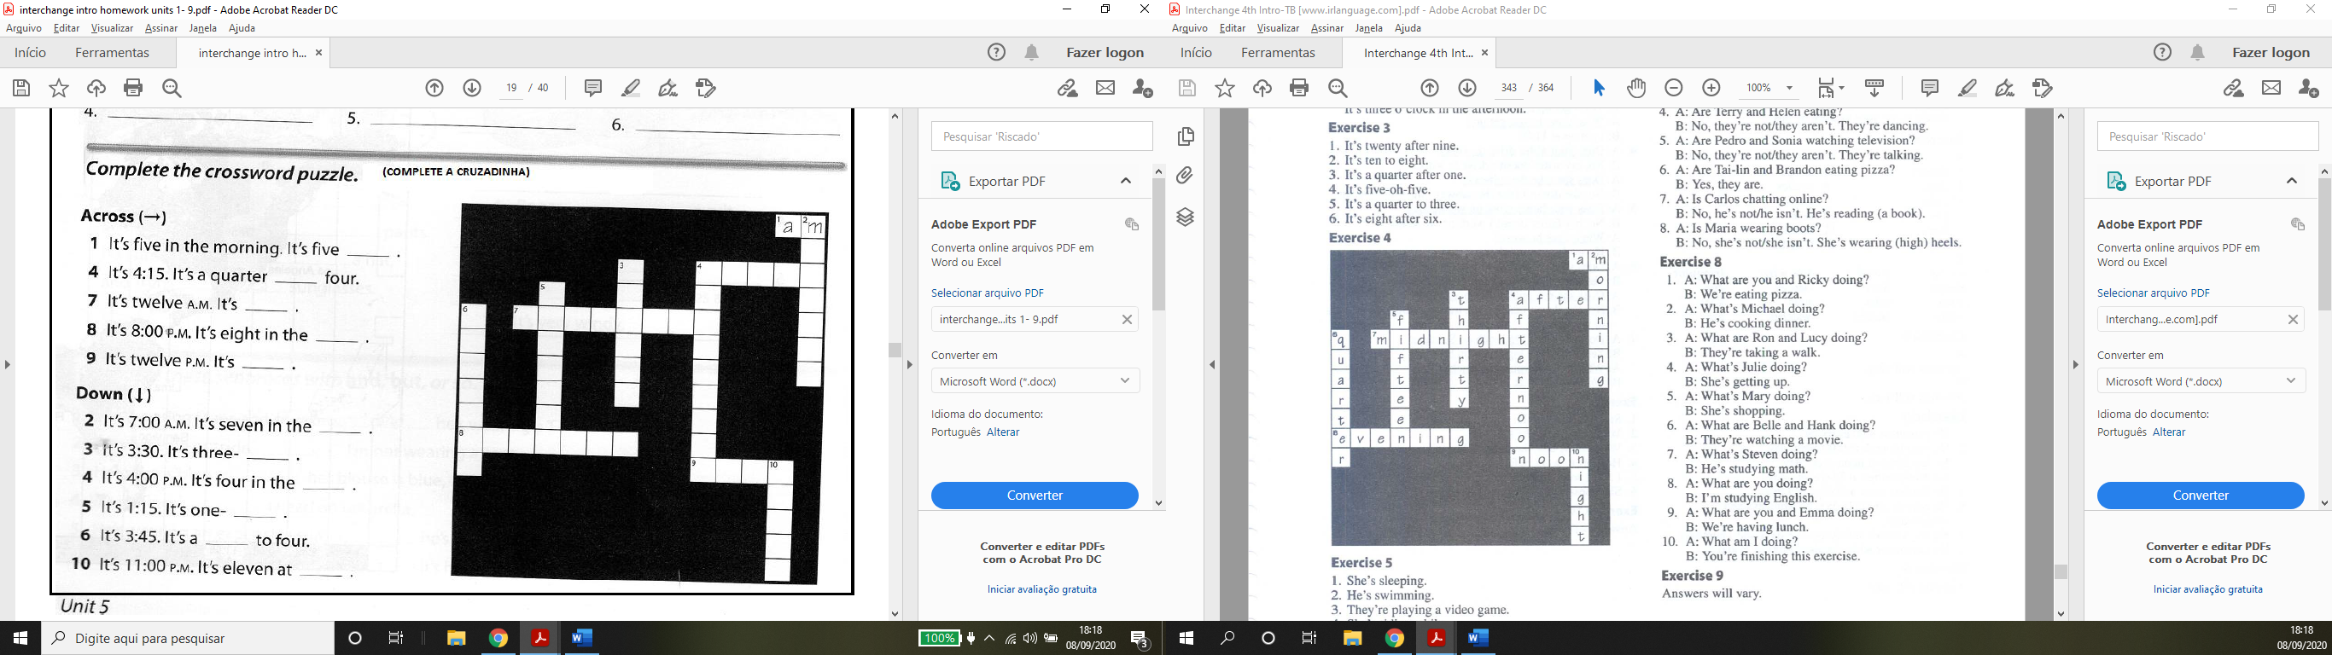

**Page 20**

**Write question about these people. Use the words in parentheses. Then answer the questions.**

1-) A: Is Terry wearing shorts? (example)

B: No, he’s not. He’s wearing jeans.

2-) A: Is Tai-lin wearing a raincoat?

B: Yes, he is.

3-) A: Is Maria talking on the phone?

B: No, she’s not. She’s sleeping.

4-) A: Are Terry and Helen eating?

B: No, they’re not. They’re dancing.

5-) A: Are Pedro and Sonia watching television?

B: No, they’re not. They’re talking.

6-) A: Are Tai-lin and Brandon eating pizza?

B: Yes, they are.

7-) A: Is Carlos chatting online?

B: No, he’s not. He’s Reading.

8-) A: Is Maria wearing boots?

B: No, she isn’t. She’s wearing heels.

**Page 21**

**Jessica is talking about her Family. Complete the sentences with the words in te box.**

1-) parentes (example) / mother / father.

2-) husband / wife

3-) children / daughters / son / sister / brother.

**Page 22**

**Complete the conversation with the correct words in parentheses**

David: live (example) / has

Marta: walk

David: don’t / take / walk

Marta: have / drive / work / Works / goes

**Third person singular – s endings**

1-) dances (examples)

2-) does

3-) goes

4-) has

5-) lives

6-) rides

7-) sleeps

8-) studies

9-) takes

10-) uses

11-) walks

12-) watches

**Page 24**

**Complete these conversations with at, in, or on. (If you don’t need a preposition, write** Ø

1-) A: Ø (example) / on

B: at / Ø / on

2-) A: in

B: in / on / in / on

3-) A: in / on

B: at / Ø

4-) A: in

B: at / in / on / on / at

Write questions to complete the conversations

1-) Dou you live alone? (example)

2-) Do you and your Family watch television in the evening?

3-) Do you get up late on Sundays?

What time do you get up?

4-) Does your sister drive to work?

Does she take the subway?

5-) Does your father work on weekends?

When does he work?

6-) Does your mather have a job?

Does she use public transportation?

7-) Dou you have a big lunch on Sundays?

What time do you have lunch?

**Page 25**

**Write each sentence a different way. Use the sentence in the box.**

1-) Sarah is Sam’s wife (example)

2-) We don’t live in the suburbs.

3-) We take the bus, the train, or the subway.

4-) He goes to work before noon.

5-) i don’t work far from home.

6-) She doesn’t get up early on Sundays.

**Answer the questions about your schedule.**

......................

**Page 26**

**Label the parts of the house**

1-) bathroom

2-) bedroom

3-) kitchen

4-) dining room

5-) living room

6-) Yard

7-) closet

8-) garage

**Complete the conversation. Use the sentences in the box.**

- No, live in an apartamento (example)

- No, it only has two rooms.

- Yes, it has a great view of the city.

- Yes, i do. I love it.

**Page 27**

**Complete the conversation with the correct words in parentheses**

Betsy: Do (example) / live

Lauren: do / live

Betsy: live

Lauren: dont / have

Betsy: Do / have

Lauren: don’t / lives

Lauren: does / cooks

Betsy: live / cook

**Answer these questions with your information. Use shorts answers.**

**................**

**Page 28**

**Answer the questions about the pictures.**

1-) Yes, she does. (example).

2-) No, she doesn’t.

3-) Yes, she does.

4-) No, she doesn’t.

5-) Yes, she does.

6-) No, she doesn’t.

7-) Yes, they do.

8-) Yes, they do.

9-) No, they don’t.

10-) No, they don’t.

11-) No, they don’t.

12-) Yes, they do.

**What furniture do you have? What furniture do you need? Write four sentences.**

**..........................**

**Page 29**

**Complete the description with ‘s, are, or aren’t.**

- ‘s

- are

- ‘s

- ‘s

- are

- aren’t

- ‘s

- ‘s

- ‘s

- are

- ‘s

- ‘s

**Answer these questions with information about your home. Use the phrases in the box.**

**Page 30**

**Write sentences about the house. Use there and the words in parentheses.**

1-) There’s no stove in the kitchen. / There isn’t a stove in the kitchen.

2-) There’s no chairs in the dining room. / There aren’t any chairs in the dining room.

3-) There’s a stove in the living room.

4-) There’s a refrigerator in the bedroom.

5-) There’s no bed in the bedroom. / There isn’t a bed in the bedroom.

6-) There are some amrchairs in the bathroom.

7-) There’s a clok in the kitchen.

8-) There are no bookcases in the living room. / There aren’t any bookcases in the living room.

**Write four more sentences about the house.**

**...................**

**Page 31**

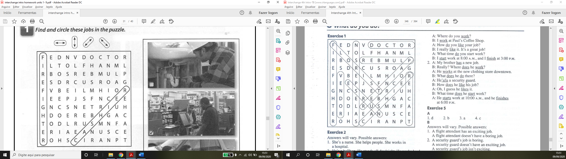

**Page 32**

**What do these people do? Write three sentences about each person. Use the phrases in the box.**

1-) She’s a nurse. She helps people. She Works in a hospital. (example)

2-) He’s a bellhop. He stands all day/night. He Works hard.

3-) He’s a vendor. He Works outside. He handles Money.

4-) She’s a police officer. She wears a uniform. She writes tickets.

5-) He’s a receptionist. He helps people. He talks on the phone.

6-) She’s a cashier. She handles Money. She Works inside.

**Page 33**

**Complete the questions in these conversations.**

1-) does you brother work (example)

Does he do (example)

2-) do Kelly and Pam do?

Do they work?

3-) does your daughter work?

Does she do?

4-) do you and Joe do?

Do you like it?

**Page 34**

**Complete the conversations**

1-) A: Do / have (example)

B: do

A: do / do

B: am

A: work

B: work

A: do / like

B: like

A: do

B: start / finish

2-) A: has

B: does / work

A: Works

B: does / do

A: is

B: does / like

A: likes

B: does / start

A: starts / finishes

**Page 35**

**Match the adjectives.**

1-) D (example)

2-) B

3-) A

4-) C

Write each sentences two different ways (answers will vary)

1-) A flight attendant has as exciting job.

A flight attendant doesn’t have a boring job.

2-) A security guard’s job is boring.

A security guard doesn’t have na exciting job.

A security guard’s job isn’t exciting.

3-) Steven has a dangerous job.

Steven doesn’t have a safe kob.

4-) A front desk clerk has a stressful job.

A front desk clerk doesn’t have a relaxing job.

5-) Linda’s apartment is small.

Linda doesn’t have a big apartament.

Linda’s apartment isn’t big.

6-) Martha has a big house.

Martha doesn’t have a small house.

7-) Sarah’s sister is talkative.

Sarah’s sister isn’t quiet.

8-) I don’t have a difficult job.

I have an easy job.

My job isn’t difficult.

**Page 36**

**Write sentences with your opinion about each job.**

**.......................**

**Imagine you have a dream job. Write a description. Use the questions in the box for ideas.**

**.................**

**Page 37**

**Write names of the foods**

1 – lemons (example)

2 – oranges

3 – apples

4 – bananas

5 – lettuce

6 – broccoli

7 – potatoes

8 – carrots

9 – rice

10 – cereal

11 – bread

12 – crackers

13 – butter

14 – oil

15 – milk

16 – cheese

17 – chicken

18 – beans

19 – nuts

20 – fish.

**What do you need to make these foods. What don’t you need? Write sentences.**

**....................**

**Page 39**

**Answer the questions with your own information**

**......................**

**Complete the sentences with the articles a or an. If you don’t need na article, write** Ø

1-) a (example)

2-) Ø

3-) na

4-) na

5-) Ø

6-) a

**Page 40**

**Put the adverbs in the correct places.**

1-) Brazilians often make drinks with fruit.

2-) Some people in Mexico never eat pasta.

3-) In China, people hardly ever put sugar in their tea.

4-) In England, people sometimes put mikl in their tea.

5-) In Japan, people sometimes have fish for breakfast / In Japan, sometimes people have fish for breakfast.

6-) Americans often put cream in their office.

7-) In Canada, people hardly ever have salad for breakfast.

8-) Some people in South Korea Always eat pickled vegetables for breakfast.